**Jahangir Tomb Photo Frame Art**

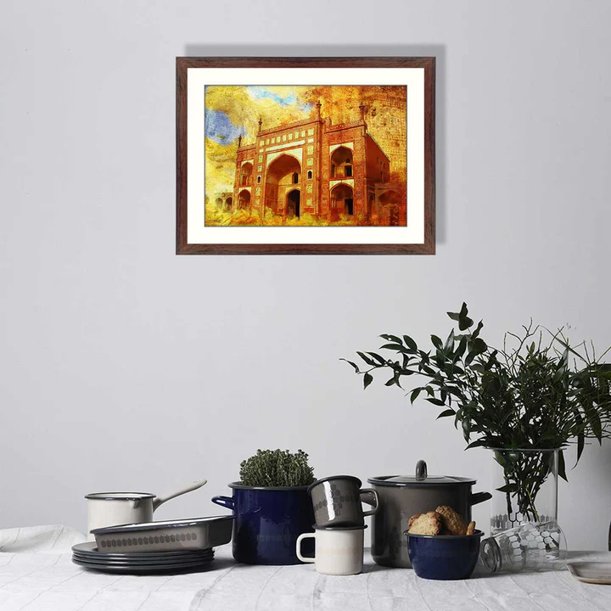Jahangir's Tomb, located in Lahore, Pakistan, is a masterpiece of Mughal architecture and a symbol of timeless elegance. Built in the 17th century by Emperor Shah Jahan in memory of his father, Emperor Jahangir, the tomb is adorned with intricate frescoes, marble inlay work, and vibrant mosaic designs. Set amidst a sprawling Persian-style garden divided by symmetrical pathways and water channels, the tomb radiates serenity and grandeur. The four towering minarets at each corner of the platform add to its architectural splendour. Jahangir's Tomb is not only a historical monument but also a tribute to the Mughal dynasty's cultural and artistic legacy.